Parachutes

Subject: Physics  Related Subjects: Mechanical Engineering | Grade Level(s): 3-5  Length of Lesson: 50 minutes | Type: Project  Keywords: Drag, Air Resistance, Gravity

Lesson Overview
Students will participate in the engineering design process by planning and creating a parachute as a solution to the introduced challenge.

Lesson Focus

What is a parachute? What is drag/air resistance?

Lesson Objective(s) | By the end of this lesson, students will…  - Understand the concept of drag.  - Identify a parachute.  - Understand the engineering design process.

Lesson Timing

15 minutes | Introduction/Lesson on Parachutes
15 minutes | Design & Build Parachute
15 minutes | Reflection/Discussion
5 minutes | Wrap Up/Ask review questions

Materials | - Rulers  - 3 pieces of paper  - 1 plastic trash bag (or reusable grocery bag, sandwich baggy, coffee filter, cellophane)  - Some string or yarn  - 1 page of newspaper  - 1 pair of scissors  - 1 roll of masking tape  - 1 figurine or small weight(Lego character, small toy) **Can make out of Paper
Teacher Prep | - Practice the lesson  - The Physics of Skydiving (Science Out Loud S2 Ep1) (additional video if time at the end of the lesson - 3:46)  - Another explanation: Playtime with Parachutes | Physics for Kids  - Have pictures/videos in the lesson plan ready to project/show students
Related Resources | - Playing with Parachutes

Lesson Plan

Introduction/Lesson on Parachutes

- Ask relatable questions like:
  - Has anyone ever seen a skydiver on TV before? For those of you who have, what might they need to land safely on the ground?
    - A parachute
- There are different styles and shapes (square, round) of parachutes as you can see in these photos. Have some photos of parachutes to show students.
  - Parachute
  - Paragliding
  - Helicopter Seeds
- Before we start the activity, we need to learn some concepts that will help us to create a parachute, by watching this video.
  - Playtime with Parachutes | Physics for Kids (end at 3:12)
- Ask questions about the video:
  - What does drag mean?
    - The force of air that pushes back/against something or someone
  - Here is a picture of someone riding a bicycle. Let’s imagine it’s a really windy day. What happens to the biker if they are biking into the wind, meaning the wind is moving towards them? Are they going slower or faster? Why is that happening?
    - Yes, going slower because of drag. *Air pushing against the biker*
  - How does a parachute help a skydiver?
    - The parachute opening up helps the air that gets trapped in the parachute and slows them down.
- If you look at this photo of the skydiver you can see where the air resistance or drag would be: https://images.app.goo.gl/eXUG7XCbeWp9rqu79
- Introduce the challenge to the students:
  - There was a recent bad storm that caused flooding, blocking the roads to and from a small town. Until the roads can be cleared, people have no way of getting food or water. Emergency workers need to drop supplies off to this town, using parachutes, as soon as possible! Your task is to design a parachute that can safely carry a skydiver.

Design/Building your Parachute

- You can make your parachute however you would like- it can be a variety of shapes, as long as it can successfully land in the small town. To tackle this task we are going to engage in the “Engineering Design Process” [project picture, and walk through each step]
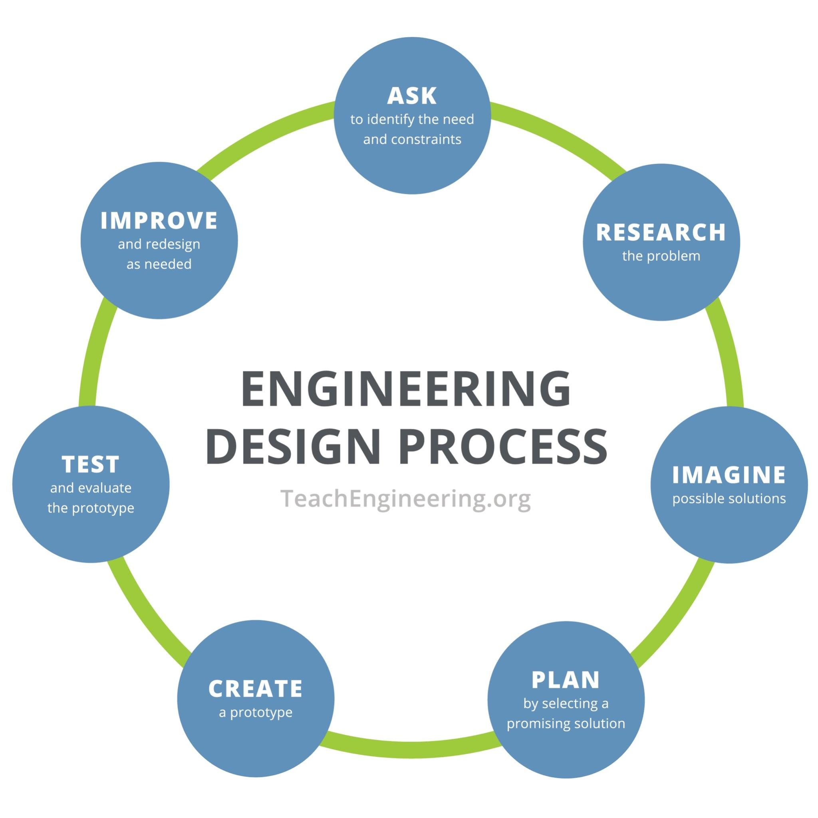
- ASK: Can anyone remind the class what a constraint is? [A constraint is something that limits us]
  - Time, limited materials, etc.
  - Remind students to keep this in mind when planning their designs
- Research: We have completed our research step from the intro videos and discussion, learning about the physics behind sky diving and forces such as drag.
- Imagine/Plan: Give students 3 minutes to sketch out parachute designs, feel free to draw out. Remind them to take into consideration their constraints and to incorporate the materials in their plan (i.e. labeling each component in their plan with a material)
- Create: After showing their designs, students will have 10 minutes to build a prototype. Remind them they can get creative and use different types of materials to make the parachute. They will also need to create a figurine out of paper.
  - Have them share? Ask: Why did you choose that material and design?
- Test: Have students create a target for their parachute - they can create a target on paper and tape it to the floor. Next, have them decide what height they will drop your parachute from. Please remember - safety first! Don’t get on top of a wobbly chair or table.
- Have students create a data table to record the following:
  - Drop Height (ft) of where you drop your skydiver. Be sure to keep the height the same for each design. (estimate if you don’t have a measuring tape)
    - you can use a long piece of string to measure the height if you’re not sure
  - Drop Time-how long does it take your skydiver to land (either on the target or near the target. Remember to make an X on the floor with tape or you can use a small book as a target.)
  - Horizontal Distance-how far was your skydiver from the target (the city)
Sample data table [can print and give to students, or have them sketch the table on paper]
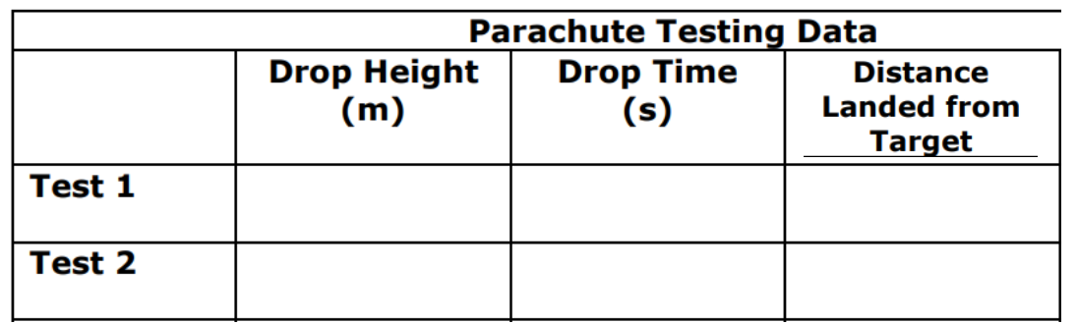

- Give 2 minutes for students to test and share results. Thumbs up if it was able to stay in the air at least 5 seconds? 10 seconds? (Remember the longer in the air the better, more time in the air to get to the city that needs help)
- Improve: Okay, now you will either change something about your first design or create a second design to see if you can get your parachute to work even better!
  - *Remember to learn from your first design and test and try to improve from your first design. Keep in mind the parachute shape, size, and materials you are using.
- When testing our second design - should we move our target for the second design and test? Thumbs up or down. Why or why not? [No, want to be able to compare results, so you can only change 1 variable]
- Should we change the height of where we drop our parachute? Thumbs up or down. Why or why not? [No, want to be able to compare results, so you can only change 1 variable]
- You have 10 minutes to complete the rest of this challenge….ready, set, go!
- Once 10 minutes pass, ask students to show the design.

Reflection/Discussion

- Recap the Engineering Design Process and how they engaged in each step.
- Have students briefly present their parachutes
- Ask questions like:
  - Why did you choose this design and that type of material for your parachute?
  - If your parachute was able to stay in the air for at least 5-10 seconds? Why do you think this is?
  - What helped your parachute to stay in the air longer? (talk about drag if students don't mention it)
  - Was anyone able to have their skydiver land on the target? What modifications did you have to make in order to make that happen?
  - If there were more time and materials, what would you have done differently to make sure your parachute stayed in the air long enough to land on the target?

Wrap-up

Forces that affect a skydiver video: GCSE Science Revision - How Forces affect a Skydiver - YouTube

Key Concepts and Vocabulary
- Drag: the force of air that pushes back/against something or someone (aka air resistance)
- Gravity: the force that pulls objects towards the earth
- Air Resistance: The force that acts in the opposite direction to an object moving through the air

