Building a Kite

Subject: Aerospace Engineering  Related Subjects: Physics, Engineering | Grade Level(s): 3-8  Length of Lesson: Month Long | Type: Project  Keywords: Aerospace, Balloon Rocket, Thrust, Drag, Lift, Gravity, Aerodynamics

Lesson Overview
Aerodynamics is the way air moves around matter. Any object that moves through air reacts to the laws and rules of aerodynamics. In this activity, students will build kites using the provided materials in order to understand the concept behind aerodynamics that allows kites to fly.

Lesson Focus
Students will learn how aerodynamics work and will review the engineering design process throughout the course of this month. They will build kites individually. The kite should be able to fly in the air during the test run after the redesigning process. Students will be able to identify how the concepts learned in class apply in real life and evaluate their own prototypes.

Lesson Objective(s) | By the end of this lesson, students will…  - Understand the four principle components of flying; thrust, drag, lift and gravity.  - Review the engineering design process.  - Apply these concepts by building kites.

Lesson Timing

Week 1 | Introduction
Week 2 | Kite Building and Test Run 1
Week 3 | Redesigning + Evaluating
Week 4 | Reflection + Discussion Questions

Materials | - Roll of tape  - 2 100 cm dowels (alternative: straws)  - 2 90 cm dowels (alternative: straws)  - 2 Sheets of wax paper  - Roll of String  - Scissors
Teacher Prep | - Introduction to Aerodynamics in Class  - Provide students with copies of the worksheets
Related Resources | - Video Intro of Aerospace Engineering  - https://www.youtube.com/watch?v=UvtYn2j78gw  - How Aerodynamics apply to kites  - https://youtu.be/NEv1HMX73N0  - Video explanation and demonstration of activity:  - https://www.youtube.com/watch?v=mc3AUuuj9_I  - Discussion  - https://www.nasa.gov/sites/default/files/atoms/files/kites_k4.pdf

Lesson Plan
Introduce students to the learning goals and make connections to past and present learning experiences. Stimulate interest and prompt students to identify their own questions about the topic. This can link the lesson to real world examples, introduce associated STEM careers, and assess their prior knowledge on the topic.

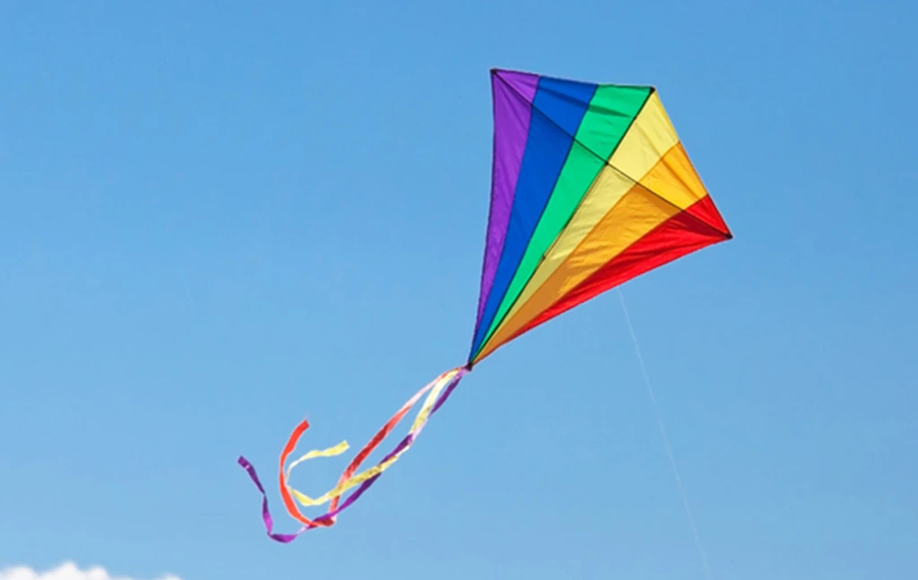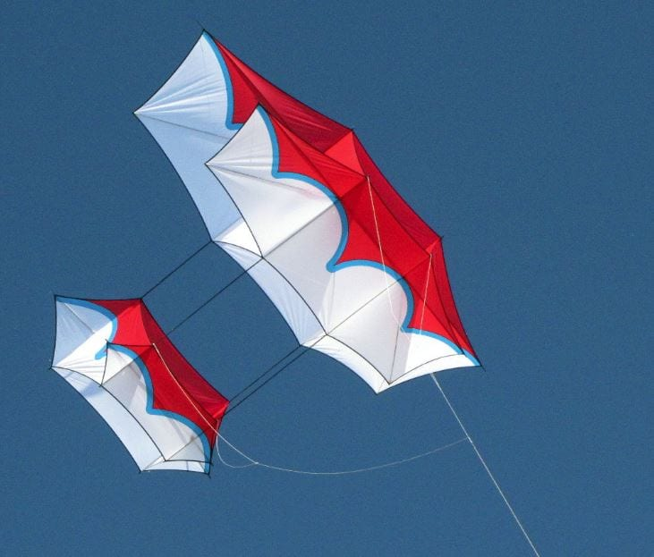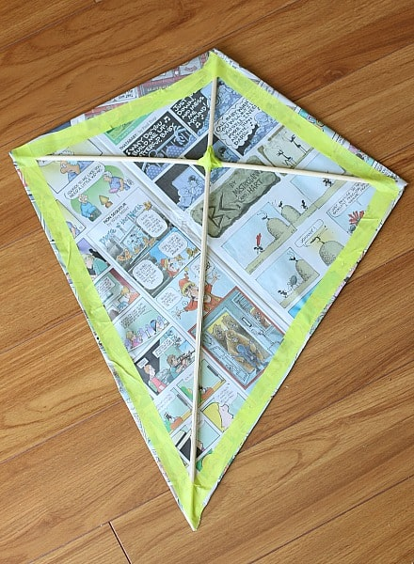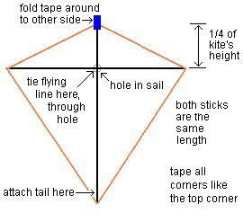

Instructions

Week 1 - Introduction
Instructions
- Have students watch the video about aerospace engineering and how the concepts apply to kites:
  - https://www.youtube.com/watch?v=UvtYn2j78gw
  - https://youtu.be/NEv1HMX73N0
- After the videos they will complete the Worksheet labeled “Week 1: Introduction”, they can replay each video as needed for better understanding.
- During this week students will be thinking about how their kites will work in real life based on what they learned from the videos and worksheet.
  - Students must identify their constraints (part of the engineering process) that could affect their kite’s performance.
  - During this week, students will be listing out what materials (from the given list) that they will need to use and how many they are expected to use.

Week 2 - Design with Video

Instructions
- Coordinate with an adult to have an open, outdoor location without trees, telephone lines or any interruptive object where students can test their kites.
- Lay supplies on the table of all 100cm dowels, 90cm dowels, sheets of wax paper and streamers. This will allow students to easily find the needed supplies, use them and return it back to the table for the next student.
- It is suggested for the students to follow along with the adult to build their kites because the pacing of the video demonstration could be too fast for all the students to follow.
- Students can test their kites at the coordinated outdoor location. Ideally, the weather outside should be a little windy. If there is no wind, the students will have to be able to run to get the lift force acting on their kites.
- Students should work with someone so that the student can hold on to the body of the kite. The other person should hold on to the string. They should unwind 20 meters of the string and stand far enough apart from their friend so the string is straight and not hanging down too much. The student holding on the kite should have their back to the wind, holding the kite by where the strings are tied together. They should let go of the kite so the wind can push it up while the other student pulls the string in the opposite direction. The student may need to run in the direction that they are pulling if there is no wind. Multiple attempts may be necessary to achieve flight.

Activity/Steps
- Cut two dowels 100cm and 90cm if you have not done so before.
  - ALTERNATIVE: Take one straw and pinch one end. Insert that pinched end into a second straw so that they overlap 1 ½ inches. Do the same with the other two straws so they, too, overlap 1 ½ inches.
- Make a cross with the two dowels, with the shorter stick (90 cm) placed horizontally across the longer stick (100cm). Make sure that both sides of the cross piece are equal in width.
  - ALTERNATIVE: Make a cross with the two “jointed” straws. Make sure that both sides of the cross piece are equal in width.

- Tie the two dowels together with the string at right angles to each other.
- Cut notches at both ends of each dowel deep enough for the string to fit into. Cut a piece of string long enough to stretch all around the kite frame. Make a loop in the top notch and fasten it by wrapping the string around the stick. Secure with tape. Stretch the string through the notch on the right cross-piece, and make another loop. Stretch the string through the notch at the bottom and make another loop. Stretch the string through the notch left cross-piece and make another loop. Wrap the string a few times around the top of the stick and cut off what you don't need. Secure the string on the notch with string. This string frame must be tight, but not bend the sticks.
- Lay the wax paper on the table and place the dowel frame face down on top. Cut the wax paper around the frame leaving a margin width of 3cm.
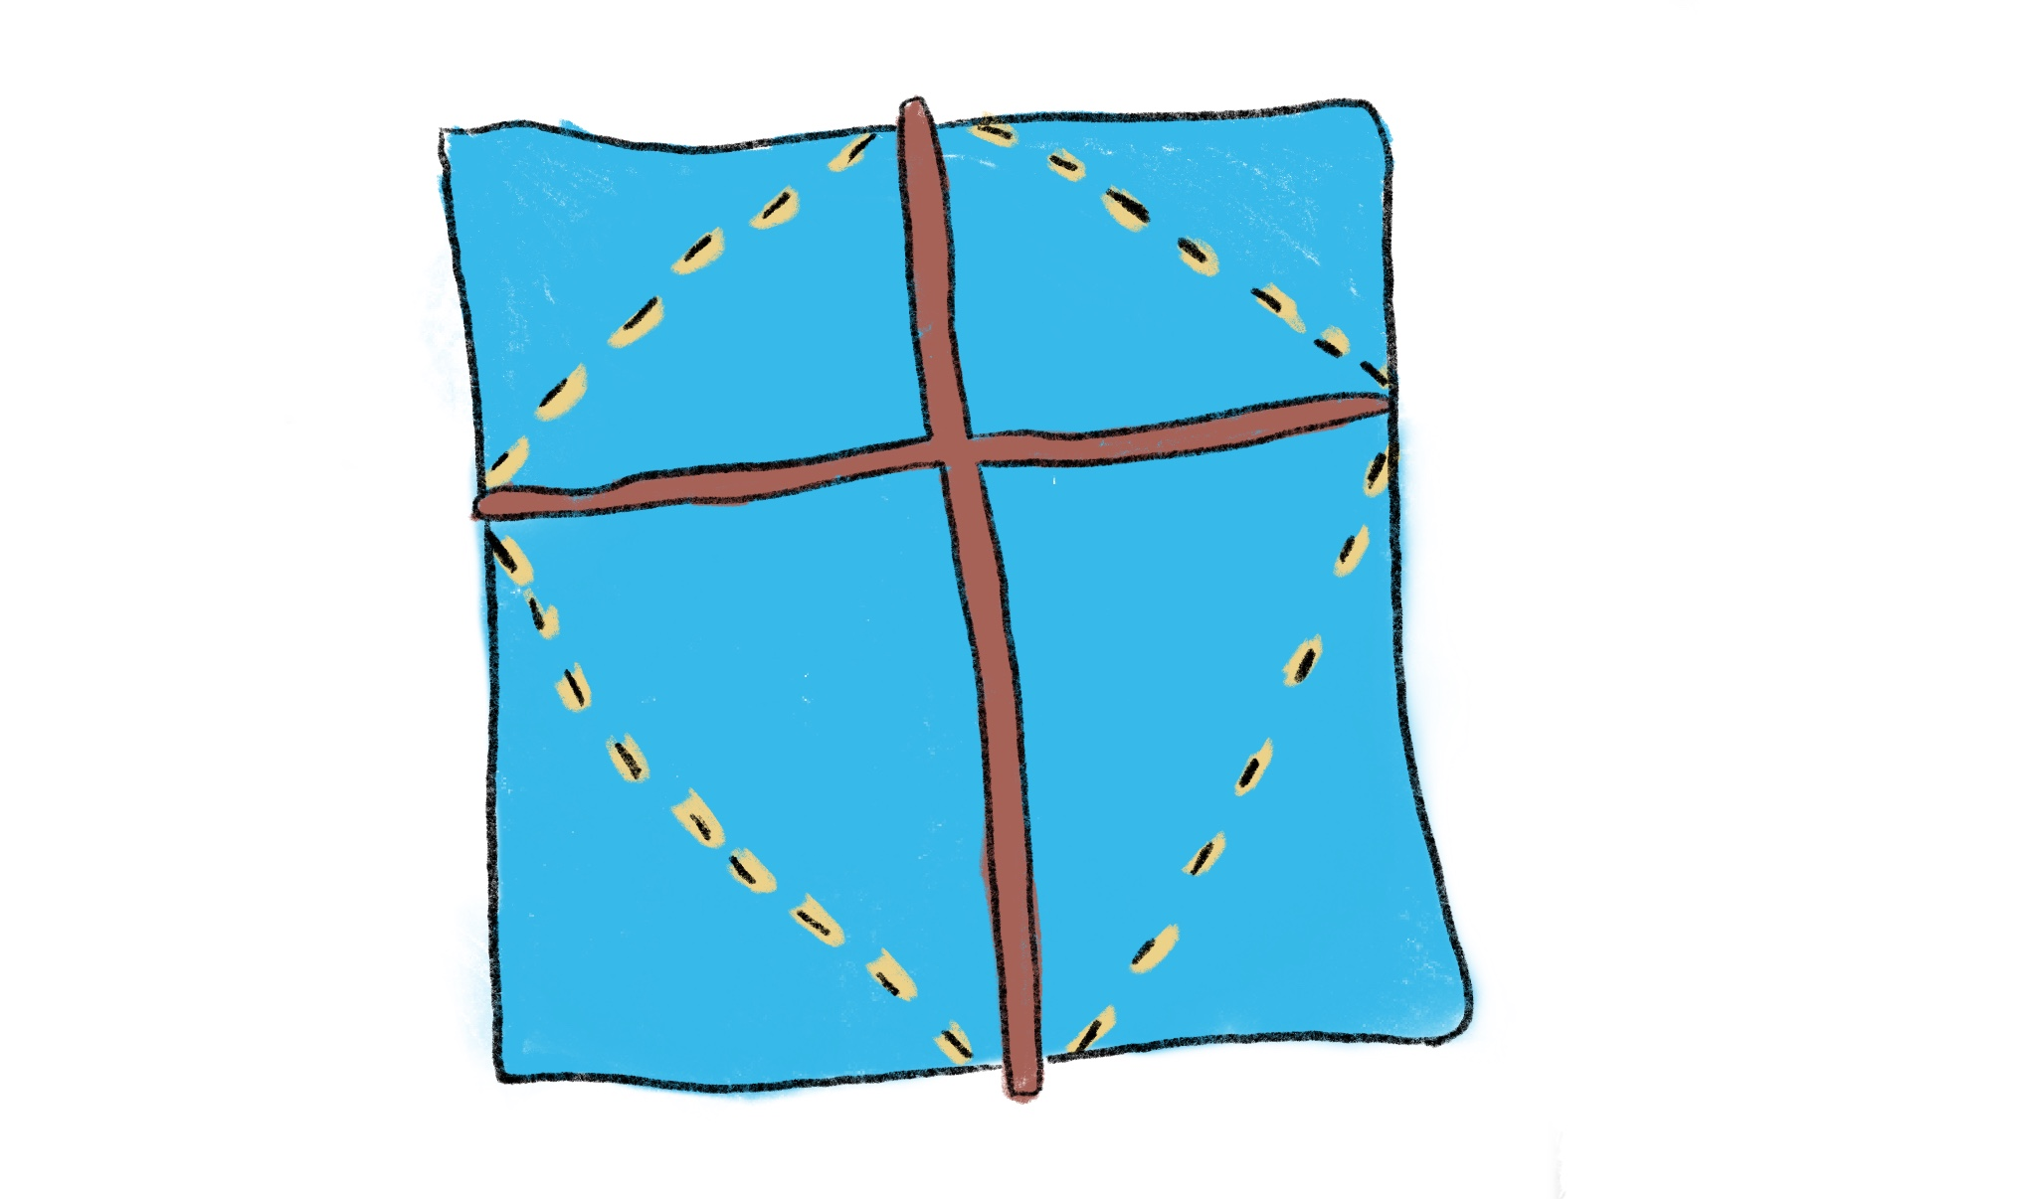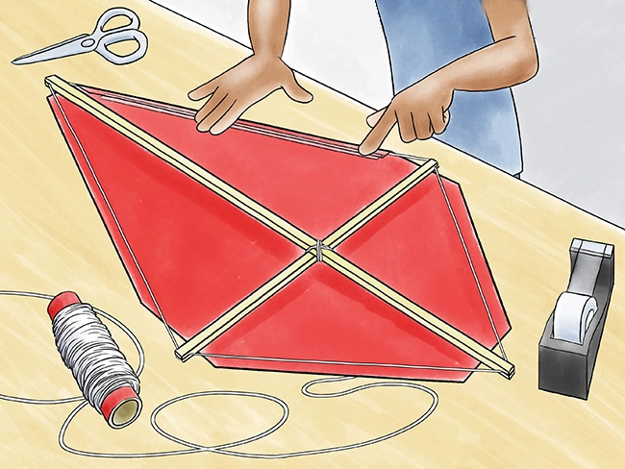
- Fold these edges over the string frame and tape down so that the wax sheet is tight.
- Cut a piece of string about 125 cm long, and tie the string to the loops at the top and bottom with about 20 cm hanging off of the bottom.
- Tie another small loop in the string just above the intersection of the two cross pieces.
- Cut a piece of string about 100 cm long, and tie the string to the loops on the left and the right through the small loop in the string just above the intersection of the two cross pieces. This will be the kite's bridle, the string to which the flying line is attached.
- Tie a small ribbon to the tail piece hanging from the bottom.
- Hold the string by the small loop in the center. The kite should be balanced from left to right. You may need to add tape to counterbalance the weight.
- Attach the flying line.
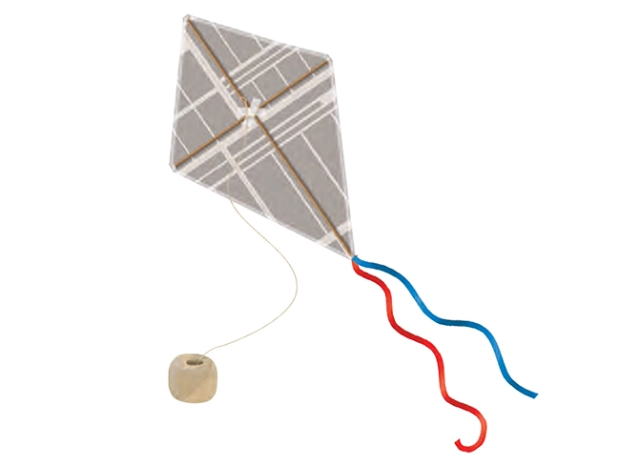
- Conduct as many flight tests as needed until the kite stays up in the air for at least 10 seconds.
- Complete the worksheet titled “Week 2: First Kite Design ” with observations.

Week 3 - Redesigning their Kite

Instructions
- Students will gather the remaining materials from the week before
  - The materials should include a 100 cm dowel, a 90 cm dowel, and a sheet of wax paper.
- This week, students will attempt to apply what they learned about aerodynamics and their first prototype from the previous week and either:
  - Completely start from scratch and build a more efficient kite (that would go higher or stay in the sky for longer time) or
  - Use the kite from last week and change some aspects of it with the extra materials in order to increase efficiency.
- Students will complete the worksheet titled “Week 3: Redesigning Time” that will include discussion questions about this week’s trials and errors as well as explanations about their design choices.

Week 4 - Reflection + Discussion

Instructions
- Students will complete a worksheet asking them about their observations
- Will also go into more detail about aerodynamics applied to other objects, animals, etc.
- Must be ready to briefly present their results and analysis to the class and answer questions such as:
  - What did you learn from this project?
  - How might you use simple machines in day-to-day life?
  - What worked with your project? What didn’t work?

Lesson Background for Teachers

STEM Connections:

Suggested Real-World STEM Connections
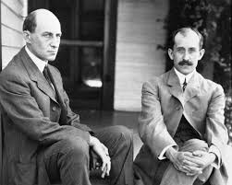
- The Wright brothers – Orville (August 19, 1871 – January 30, 1948) and Wilbur (April 16, 1867 – May 30, 1912)
- Aviation pioneers generally credited with inventing, building, and flying the world's first successful motor-operated airplane
- During World War I, Europeans used kites to gather military intelligence and to direct artillery fire
- By the end of the war, airplanes had replaced kites for scientists and the military.
- Airplanes are able to achieve flight as kites. In order to overcome drag forces, an aircraft must generate thrust. This is accomplished with a motor-driven propeller or a jet engine. When the airplane is in level flight at a constant speed, the force of the thrust is just enough to counteract the aerodynamic drag. Through this technology, people can travel in massive altitudes, thousands of feet above ground.

Explanation
Kites fly by the rules of aerodynamics, the interaction between objects and air. There are four main forces involved in the kite’s flight: lift, weight, thrust, and drag. Most basic kites are big and flat with a long tail. They are connected to a long piece of string which you can hang on to so you can control how they fly. How the kite stays up in the air has to do with the big flat part of the kite, also known as the sail. As the kite flies through the air, the sail is tilted so the back of the kite is a little bit lower than the front of the kite. The tilt is really important for keeping the kite in the air because it changes the way the air flows over the sail. As the air flows past, it pushes on the sail but because the kite is tilted the air rushing past the bottom of the kite pushes up on the kite harder than the air flowing past it on the top. This is known as the kite’s lift as it is caused by the differences in pressure when air flows over and under the sail. The lift is opposed by weight, or the force of gravity that is constantly pulling downward on the kite. With the air pushing up on the bottom of the sail, the kite is staying in the air without falling down. The tail weighs down the bottom side of the sail which keeps the kite tilted so the air pushes up against the kite to keep it flying. When a person is controlling the motion of the kite with the flying line, there is a thrust acting on the kite, where thrust is caused by the tension from the person pulling the flying line of the kite forward with some help from wind. Opposed to thrust is drag, which comes from air resistance. If lift is greater than weight, the kite will rise. If thrust is greater than drag, the kite will accelerate (speed up). The interaction between those four forces is how a kite can move up and forward.

Key Concepts and Vocabulary
- Aerodynamics
- The way air moves around things.
- Anything that moves through air reacts to the laws/rules of aerodynamics.
- Force
- Push/pull on an object.
- Expressed in Newtons.
- Mass x acceleration.
- Gravity
- Earth’s pull on an object (always downward).
- Force caused by a large body.
- Tension
- A pulling force that is caused by a string/cable/attached object.
- Drag
- The backward force that acts opposite to the direction of motion.
- Caused by the difference in air pressure between the front and back of the kite.
- Thrust
- The forward force that propels a kite in the direction of motion.
- Lift
- Upward force that pushes a kite into the air.
- Made by differences in air pressure, which are created by air in motion over the body of the kite.

