L1: Balloon Spacecrafts

Subject: Aerospace Engineering  Related Subjects: Physics | Grade Level(s): 3-8  Length of Lesson: 50 min | Type: Project  Keywords: Flight, thrust, drag, propulsion, force, Aerospace, Newton’s laws

Lesson Overview
Students use an air-powered rocket that travels along a string to learn about the forces of flight: lift, thrust, drag, weight. The goal is for groups to propel their rockets as far as possible on a "tank" of fuel (in this case, the tank is air). In doing this, students determine a relationship between the amount of fuel (air) and the distance the rocket travels.

Lesson Focus
Students will be constructing balloon rockets that hold cargo and travel a certain distance.

Lesson Objective(s) | By the end of this lesson, students will…  - Learn about the forces of flight and understand their importance in engineering.

Lesson Timing

5 minutes | Set up and introduction to aerospace
5 minutes | Identify the problem we’re trying to solve and how it’s relevant to us
5 minutes | Introduce the activity
15 minutes | Build cargo holders for balloon spacecrafts
10 minutes | Test cargo holders
15 minutes | Reflect and introduce vocabulary
5 minutes | Complete post-lesson surveys

Materials | - 1 Balloon (per group)  - 1 Clothespin, binder clip, or rubber band (per group)  - 1 straw (per group)  - 8 paper clips  - 2 pieces of Cardstock (per student)  - Scissors  - Tape  - 5 long pieces of string (for the whole class)
Teacher Prep | - Allow the students a small period of time to blow up their balloons after the activity, but don’t let them become disruptive. Keep the air in using a clothespin, binder clip, or rubber band (don’t tie)  - Place individual and group materials at tables before students arrive.  - Bring extra materials (balloons, straws, weights) in case any break.  - Set up the strings that students can suspend their balloons from for testing -- can use chairs or tables to attach strings to (see image below for example):  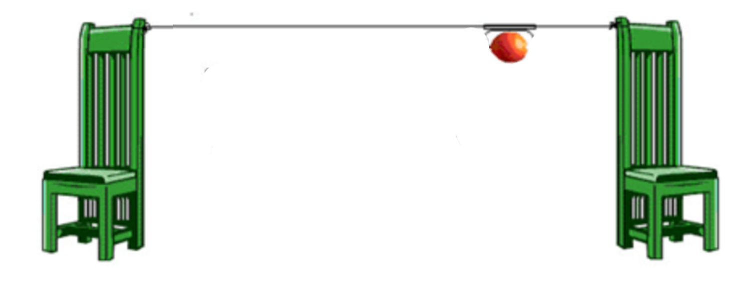
Related Resources | - NASA’s The Four Forces of Flight: https://www.nasa.gov/audience/foreducators/k-4/features/F_Four_Forces_of_Flight.html  - Action-Reaction Rocket! (for Informal Learning) - Sprinkle - TeachEngineering  - VIDEO if students need additional context/an example

Lesson Plan

Introduction

- Begin by making a connection to the students. Ask them about what sports they play!
  - Raise your hand if you like playing baseball or softball.
  - Who likes throwing around a Frisbee?
  - Have you ever wondered why some objects, like Frisbees, stay in the air for way longer than a baseball?
- Aerospace is the human effort to fly in the atmosphere of Earth and surrounding space. To do so, we use aircrafts and spacecraft and rockets!
- Rockets and rocket-propelled flight have been in use for more than 2,000 years. People in ancient China used gunpowder to make fireworks and rockets. In the past 300 years, people have gained a scientific understanding of how rockets work. Now with advanced technology, aerospace engineers make rockets fly farther, faster, higher and more accurately. Our understanding of how rockets work arises from Sir Isaac Newton’s three laws of motion. It is important for engineers to understand Newton’s laws because they not only describe how rockets work, but engineers also explain how things move and stay in place!
- Today we are going to build air powered rockets!

Procedure
- Pre-lesson set-up
  - Attach a string to two objects with a measured distance between them (i.e. 10 meters).
    - Additionally, place tape along the ground to mark partial distances (i.e. 1 meter, halfway, etc.).
  - Lead the string through a straw so that the straw hangs on the string between the two objects.
  - Set out a piece of cardstock for every individual student.
  - Set out 2 pairs of scissors and 1 roll of tape for every table or group of students.
- Today, you are all going to be engineers stationed on the planet Mars. We want to send some cargo back to Earth from Mars, but we need to make sure that our spacecraft can make it the whole distance.
  - What are some examples of cargo we might be sending from Mars to Earth?
  - Some potential answers: Data samples like rocks and other materials, people returning from Mars, damaged parts that need repairing or can be salvaged for another craft
- Your job is to build a cargo holder that can hold a certain amount of weight stable (show students the weight they’ll have to carry). We’ll insert the weight before you test your cargo holder.
- Here’s what the spacecraft alone will look like! It’s your job to attach a cargo holder to the top that carries the weight I just showed you.
  - While you do this, test the activity with a balloon and no cargo holder on the string.
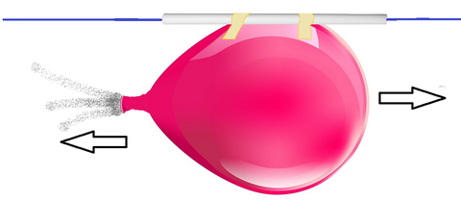
  - The balloon spacecraft may look more like this with a cargo holder attached (cargo holder can also be attached to below:
- You have about fifteen minutes to build your cargo holders with your group. You each have a piece of thick paper, and your groups have scissors, tape, and paper clips.
- You can use all of the paper that your group has or a single piece. You could make an open box or you could use more material to make a box with a lid. There are lots of decisions to make and any one of them requires some sacrifice. Make sure to brainstorm collectively before getting started, and good luck, engineers!
- During the activity: Walk around tables and ask groups what they’re doing. Make sure that everybody in a group is involved.
- Testing cargo holders: While one group is testing, everyone else should be seated at their table observing.
  - Use a new balloon for every group to keep the activity sanitary as it will need to be blown up for each test
  - Let each group use their tape to attach the cargo holder to the top of the spacecraft.
  - Place the weight in the cargo holder.
  - Let the group count down until you release the balloon.
  - Note: Many students will be excited to set up the launch themselves. Allow groups only to attach their cargo holders, then you must individually place the weight and release the balloon, or students will feel as though they’re missing out if they don’t get to do it while some others

Wrap-up
- Let’s think about the activity we just completed! Why do you think some spacecraft didn’t go as far as others?
  - The shape of the cargo holder slowed it down, some cargo holders were heavier, etc.
  - There are two principal components of flying that can slow objects down. One is called drag and the other is gravity.
    - Can anybody tell me what drag is? (Drag: Force that acts opposite to the direction of motion. Drag from the air makes the balloon slow down!)
    - Can anybody define gravity for me? (Gravity: Gravity causes the force we call weight to make objects fall down. The weight of the spacecraft makes it fall toward the ground.)
- What would you do in the future to improve your spacecraft, and why do you think some did better than others?
  - Make the cargo holder a better shape, blow up the balloon more, etc.
  - There are two principal components of flying that can speed things up. One is called lift and the other is thrust.
    - Does anyone have a guess for what lift is? (Lift: Force that holds an object in the air. The shape of an object, like the wings of an airplane, can hold it up.)
    - Finally, can anyone tell me what thrust is? (Thrust: Force that moves aircraft in the direction of motion. The air coming out of the balloon gives it thrust!)
- So, we just learned about the four principle components of flying. Could someone list them for me?
- Let’s come up with a good way to remember those components! Everyone, please stand up.
  - Come up with motions for each component. (Thrust could be a jump, lift could be raising your arms, drag might be pulling yourself back, and gravity could be bending or falling down.)
  - Repeat each individual motion with the students, then all of them together.
- Great job, everyone! Now, let’s return to what we were thinking about originally: sports.
  - Why might a Frisbee stay in the air longer than a baseball? (Thrust of your arm, lift due to the shape)
  - Meanwhile, why does a baseball fall down faster than a Frisbee? (Gravity/weight of it)
  - Why is it easier to throw a Frisbee or a baseball far in comparison to throwing a basketball? (Drag due to its larger surface area against the air)
- The questions you ask yourself about throwing a Frisbee to a friend or shooting a basketball are the same questions that aerospace engineers have to ask themselves when designing spacecraft.

Present Real-World STEM Connection
- Related role model in STEM: Franklin Chang-Díaz
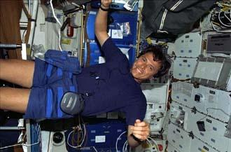
  - Franklin Chang-Díaz was born in Costa Rica and moved to the U.S. to get a degree in electrical engineering. He then attended MIT to get a Ph.D. in applied plasma physics.
  - Chang-Díaz went on to become the first Latin American immigrant NASA Astronaut selected to go into space. He participated in seven Space Shuttle missions, which is the record count.
  - He’s a great example of someone who studied something other than aerospace engineering but was still able to enter this profession. There are many related subjects that you can study if you want to work with air- and spacecraft.

Explanation
- The key components for rocket design are: thrust, aerodynamics, weight, and guidance.
- Thrust can come from internal combustion or external force.
- The aerodynamic shape should include a nose cone and a cylindrical body. As air passes over the rocket, it will take the path of least resistance. In addition, an aerodynamic design will decrease drag.
- For a given thrust, a lighter rocket will travel farther. Any weight must be properly distributed to maintain stability.
- Guidance (direction) and stability can be achieved by the fins. The fins, when properly aligned along the axis of the rocket, contribute to the stability of the rocket by maintaining a consistent direction. The student can use 3 fins (placed 120º apart) or 4 fins (placed 90º apart). The fins use wind resistance to maintain a straight course.
- When properly constructed, the rockets will follow a parabolic curve, called its trajectory, from launch to landing. The rocket is considered a projectile because it is an object (given an initial speed) moving through space. Its path is determined by gravity and wind resistance (drag). This projectile motion is a combination of positive horizontal and vertical motion (due to initial thrust) and negative vertical motion (due to gravity).

Key Concepts and Vocabulary
- Aerospace: Human effort to fly in the atmosphere of Earth and surrounding space.
- Thrust: Force that moves aircraft in the direction of motion.
- Drag: Force that acts opposite to the direction of motion.
- Lift: Force that holds an object in the air.
- Gravity: Causes the force, weight, to make objects fall down.

