L3: Whirly Birds and Paper Loops

Subject: Aerospace Engineering  Related Subjects: Physics | Grade Level(s): 3-8  Length of Lesson: 50 minutes | Type: 2 mini-projects  Keywords: Aerospace, Loop Gliders, Thrust, Drag, Lift, Weight/Gravity

Lesson Overview
Students will explore how the concepts of lift, drag, and gravity play into helicopter flight., creating motorless helicopter models. Students will then create paper loop gliders--obscurely-shaped flying vessels--to review all 4 forces of flight: lift, thrust, drag, weight/gravity.

This lesson explores how helicopter flight is possible and how helicopters and drones in today's world have impacted technological advancements. Students will discover the key concepts of helicopter and drone flight while learning how certain material choices and designs could have an impact on the effectiveness of their prototypes.

Lesson Focus
Students will first focus on helicopters, how they fly, why they are used, and how they are used in different ways to help people and the environment. Teams of students will discover helicopter flight while designing, building, and testing their own samples out of basic materials. Then students will end by constructing paper loops to review all 4 forces of flight.

Lesson Objective(s) | By the end of this lesson, students will…  - Understand thrust, drag, lift, and gravity and their effect on moving objects such as helicopters  - Learn about engineering design, testing, and redesigning.  - Explain and understand Newton’s Laws of Motion

Lesson Timing

3 minutes | Introduce the Lesson
7 minutes | Newton’s Law of Motion and simple physics lesson
10 minutes | Design Whirly Birds
5 minutes | Test & Discuss
10 minutes | Design Paper Loops
5 minutes | Test & Discuss
10 minutes | Conclusion and Real world STEM connection

Materials | - 3 Sheets of printer or construction paper  - 1 Printed copy of template: whirly-bird-template.pdf  - 4 Paper clips  - 1 Pair of scissors  - 1 Straw  - 1 Roll of Tape  - 1 Ruler
Teacher Prep | - Practice building the paperloop prior to presentation  - Give very clear instructions about working with scissors and other safety hazards
Related Resources | - Make a "Whirlybird" from Paper  - Hoop Glider/Airplane STEAM Activity : 4 Steps (with Pictures) - Instructables  - VIDEO [Paper loop]: How To Make A Hoop Glider | Lab 360 - YouTube  - VIDEO [Whirly Bird]: Make a Whirlybird from Paper - YouTube

Lesson Plan

Introduction

- Get the students engaged by asking some questions related to the lesson.
  - Has anyone seen a drone or a helicopter before?
  - How do they think helicopters and drones stay in the air?
- Show students examples of helicopters and drones and give them time to identify different parts of the aircraft.
  - Show without labels first
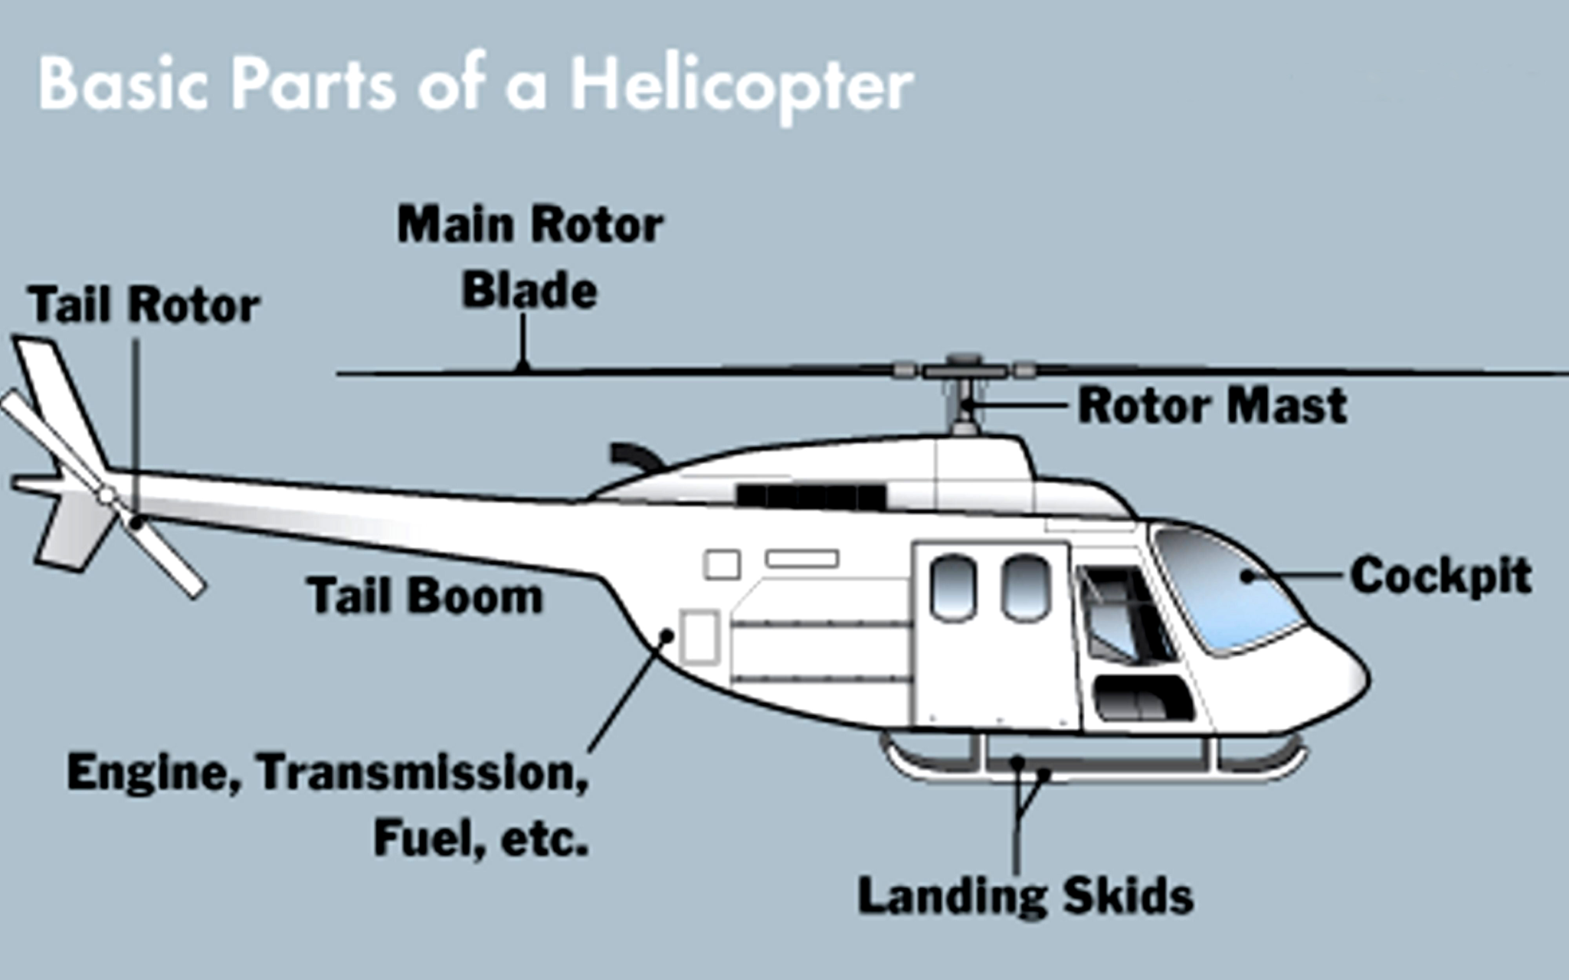

Lesson on Physics

- Before we start the physics lesson, let's keep the conversation going.
- Ask students:
  - Can anyone describe what gravity is or what it does?
  - Does anyone know how lift, thrust and drag play a role in the concept of gravity?
  - Which do you think moves faster: a light aircraft or a heavy aircraft? Why?
    - First, take a couple responses. Then explain how adding weight to an object will increase the gravitational force and make something move slower.

In order to refresh the concept of lift, thrust, drag and gravity/weight, can use the following analogy.

- Has anyone gone on a plane before? There is wind hitting the front of the plane as it moves through the air. This is known as resistance and drag. If there is wind coming from behind the plane, pushing the plane forward, it will help it go faster. This is what we call thrust. There is also the force of gravity, which pulls the plane down. The heavier the plane is, the greater the force of gravity. Lastly, we have lift. Lift comes from the air that goes under the plane, lifting up into the air.
  - Have the students define the four terms first, then clarify any definitions if what the students said was confusing.
    - Thrust: Force that moves the object through space. It can be externally applied or result from an internal source. For example, engines create thrust.
    - Lift: Mechanical force generated by a solid object moving through a fluid.
    - Drag : Wind resistance on the object as it moves through space.
    - Weight/Gravity: Natural force that pulls the object down; gravitational attraction of the Earth. Gravity allows a building to stand on the ground and an apple to fall.
- Unlike a real helicopter, the whirlybird does not have a motor to make its blades spin and thus has no thrust. However, due to its special shape, the blades will still spin as it falls. This creates additional lift that slows the whirlybird even as it drops. So, it will fall much slower than if you crumpled up the same piece of paper and dropped it.
- Ask an application question:
  - Do you think adding paper clips as weights to the whirlybird will make it fall faster?
- Try it if there is enough time.

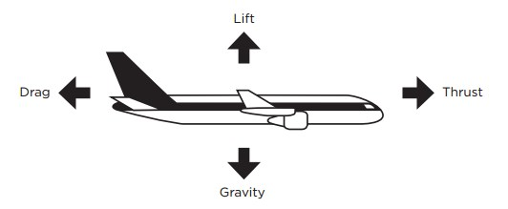

Helicopters stay in the air using spinning blades that are used to generate lift. With enough of it, a craft can overcome the force of gravity, which pulls the object down toward Earth. Helicopters have spinning blades called rotary wings. On the other hand, traditional airplanes have fixed wings.

Questions for students:
- If lift and thrust are stronger than weight and drag, what will happen to the aircraft?
- Will adding weight to the aircraft make it fall faster?

This ties directly to today’s lesson; Newton’s laws of motion. Present these laws:
1. The first law of motion states that objects at rest will stay at rest and objects in motion will stay in motion unless outside forces acted upon them.
  - You see this all the time. The school bus does not move until the bus driver puts the key in the ignition, turns on the car, and starts driving.
  - In our case, the balloon-powered cars we will build today will not move until we blow some air into the balloon, pinch the straw for a second, and then let it go!
2. The second law of motion states that the greater the mass of an object, the more force it will take to accelerate the object.
  - We also see this all the time in the real world. The school bus is heavier than our parents' personal cars, and therefore, it is most likely slower.
  - In our case, the larger and heavier the cardboard we use for our cars, the slower it is for the car to move. Therefore, one way to build a faster balloon-powered car is to use a smaller cardboard than the one described in this lesson.
3. The third law of motion states that for every action there is an equal and opposite reaction.
  - The easiest way to understand this is to look at a plane when it is flying. While the plane is flying, it is pulled down by gravity. However, there is an opposite and equal reaction. Lift pushes the plane up, keeping it in flight and in the air. We can also see this when we think of drag and thrust. Drag is working to push the plane back while thrust is working to push the plane forward. Here, we can see how every action has an equal and opposite reaction.

Design & Build

Building Whirly Birds (Motorless Helicopter)

- Time to design our whirly birds to see these forces of flight in action! Here are some examples for inspiration.
  - Demonstrate by making it in front of them!
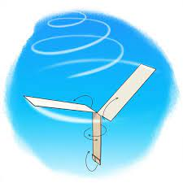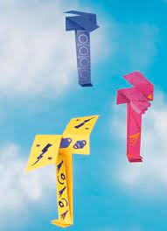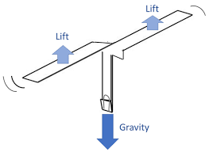

Note: Make sure to print copies of this template for students’ use before class: whirly-bird-template.pdf (sciencebuddies.org) OR project this step by step tutorial if unable to print. Make sure to demo it for the students. Additionally, video tutorial HERE if needed.

Alternatively, follow these steps:
- Take a 4”x11” piece of paper (roughly 1/2 the length of a sheet of paper).
  - The 4” side should be towards you.
- Measure and cut about a 5” slit down the center of the paper, from the 4” side.
- Mark edges at the end of the slit on opposite sides.
- Cut a 1” slit in from each edge at the marks.
- Fold in the sides below the slits toward the center; they will overlap.
- Use tape to attach the two folded sides together.
- Fold the bottom edge up twice, 1” at a time and fasten with paper clips.
- Fold one flap toward you and the other away from you.
- Throw whirlybird straight up in the air to make it fly downward.
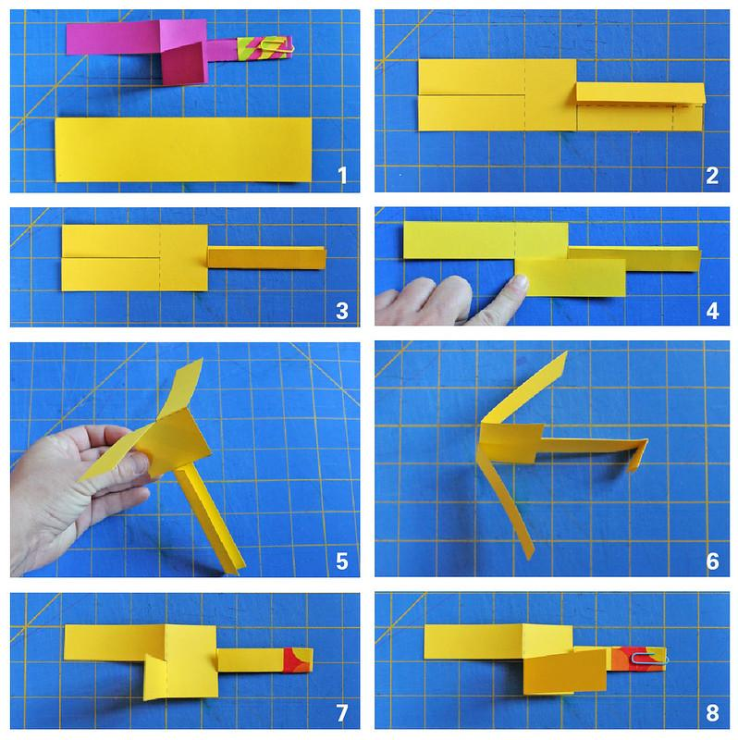
Since the whirly birds are being dropped and have no motor, they leave out the thrust force of the forces of flight. Let’s complete one more activity that demonstrates all 4 forces of flight to drive home these concepts. This activity will create an obscure shaped flying object and demonstrate all 4 forces of flight in action.

All forces work together for the paper loop to fly, how a paper loop flies depends on the strength and direction of thrust, drag, gravity, and lift! If lift and thrust are stronger than gravity and drag, the paper loop will go up. If gravity and drag are stronger than lift and thrust, the paper loop will go down. In this activity, the force the paper loops are thrown with is thrust.

Designing Paper Loops [Video tutorial attached HERE if needed]:

- Coordinate to have an open location, indoors or outdoors, without any interruptive objects so students can test their gliders.

- Cut a 3x5 card or stiff paper into 3 equal stips that measures 1 in x 5 in
- Form a loop with 1 strip and tape to one end of straw
- Tape the remaining two strips together lengthwise and form a larger loop
- Carefully align larger loop with small loop and tape to straw
- Fly glider and make adjustments as necessary | 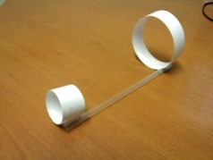

Test Run!
- Test aircrafts by throwing them from the same spot repeatedly
- If there is enough time left, answer the following questions:
  - What happens when you throw it with the smaller loop in the back?
  - What about with the straw on top instead of closest to the ground?
  - What would happen if you add an extra loop in the middle?
  - What about taping another straw to the one you have to make it twice as long?
- Make another paper loop and attach them together.
  - What happens?
  - How is it different from a single paper loop?

Discussion
- Have students briefly present their finished paper loops to the rest of the class.
- Ask students for a thumbs up if it worked and thumbs down if it did not work.
  - Many may have thumbs down, let them know that is perfectly okay!
    - In fact, this is what always happens in the real-world. We build, test, learn from our mistakes, and then, improve our designs. This is what we call the engineering process!
- Identify someone's paper loop who worked well and ask the class why they think it was the most successful.
  - Why do you think it worked the best?
  - How was the material effective? Apply the concepts learned during the lesson.
  - Knowing that now, how would you improve upon your design for the next try?
- Explain the activity:
  - While the paper loops may look odd, they fly well. The two sizes of hoops help to keep the straw balanced as it flies. When you throw the plane, you are giving it thrust. The big hoop creates drag, or air resistance, which helps keep the straw level. The smaller hoop at the front keeps your hoop plane stable and flying on a straight path. When you throw it there is just enough lift to keep the aircraft gliding along and slow its fall to the ground as gravity pulls it towards the Earth. Thrust, drag, lift, and gravity/weight are the four forces of flight, as illustrated in the image with the airplane above. All flying things balance these forces to be able to fly through the air.

Wrap-up
- Have students compare and contrast the flight of the whirly birds with that of the paper loops.
- Make suggested real work STEM Connection.

Suggested Real-World STEM Connection

- Isaiah Cooper
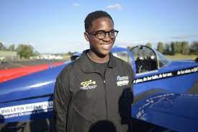
  - A 17-year-old pilot, the youngest African American to fly across the U.S.
  - Video

Key Concepts and Vocabulary
- Thrust: a force that moves the object through space. It can be externally applied or result from an internal source.
  - Ex. Engine,
  - In our case, the force of throwing the paper loop.
    - Whirly bird has no thrust component since it is just being released.
- Lift: mechanical force generated by a solid object moving through a solid.
- Drag : the wind resistance on the object as it moves through space.
- Weight/Gravity: a natural force that pulls the object down; gravitational attraction of the Earth.
  - Force that allows us to stand on the ground and an apple to fall.
- Aerodynamics: the study of the interactions between the air and the solid objects moving through the air.

